Penhold School
Parent Advisory Council
Tuesday, February 7th, 2023
Minutes

- Meeting Called to Order at 7:44 PM by President, Amanda Wilson.
- Members Present: Amanda Wilson, Nora Holben, Giselle Meyer, Natasha Caissie, Ken Denson, Jenna Murphy

- Approval of Agenda for meeting Feb 7th, 2023
Motion to approve the Agenda.
Moved by: Nora
CARRIED

- Approval of the Minutes*, as presented (OR as amended)
  - January 17, 2023
Motion to approve the Minutes.
Moved by: Nora
CARRIED

- Financial Report: Treasurer – Natasha Caissie
  - Review of the Treasurer’s Report January
- 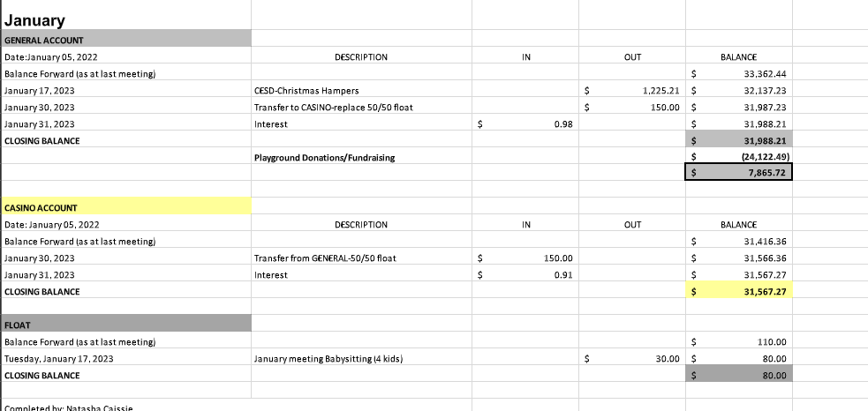

- Separated out the playground funding on the balance sheet
wondering if there should be a separate bank account for the playground funding
- look into AGLC specifics about using money for the playground fundraising
- CRA - going to mail off the annual report
- Needing to determine if all fundraising is going to the playground

Motion to approve the Treasurer’s Report, as presented.
Moved by: Nora
CARRIED

Motion to pay babysitters $20 for coming, $30 if there are 5 or less kids, $40 if there are 6 or more kids.
Moved by:Natasha
Seconded:Nora
Carried.
- Executive Report:
  - Correspondence
    - Correspondence that came is a reminder that the CRA report is due
will be mailed to CRA soon

- Fundraising Report – Fundraising Coordinator
- The Mixing Spoon
  - There has been 1 EMT come in so far
  - Hoping that all of the orders will come in later this week
  - Shared on Facebook and on PES website today
  - Chris Wolfe has offered to pick them up from Calgary to bring them home. Nora to connect with him when we have a date.
- Paint Night with ABC Creations
  - looking at having it at the Penholder
  - Potentially $50 at a cost
  - Wondering if it is too high of a cost and/or too late in the year to plan this fundraiser
  - Recommending to push it to the fall
- Walmart Grants
  - Fiscal year is over and would need to reapply
  - Previously applied for in North Red Deer, South Red Deer, Olds and Sylvan Lake
  - Should reapply for all of them

Motion to re-apply for the 4 Walmart Grants
Moved by: Amanda
Carried

- Spaghetti Night
  - Seniors Drop in Center - $125 for the day, has kitchen that can be accessed
    - will fit 65-70 people
    - could do an early dinner and later dinner
    - only day booked is May 22
  - Check and see if the Memorial Center can be donated to the school
  - Possible dates: End of April/Beginning of May, What day of the week would work best? Are we having door prizes? Who in the community will we reach out to help with door prizes?
    - Having it on a weeknight will be challenging for PAC members
    - May 2nd, 4th, 9th are possible dates to check on
    - Cost break down is needed in order to determine if there will be enough money made to make this worthwhile
- Bake Sale
  - Could a message be sent out to parents through messenger specific with the link to the Google Form
  - Need help with organizing food to sell during the day and at night
  - Parent will be needed at the school during lunch to oversee the sale of items
    - School leadership kids will help sell
  - Some parents will be here on March 8th to help organize the food the night before
  - Will need small round stickers, will need plastic gloves, napkins
    - a float will be needed
      - if money has to be removed, 2 council members will need to go to the bank to get it

- New Business
- No other new business

- Next Meeting Date and Adjournment
- Next Meeting will be March 14th at 7:00pm.
- Meeting Adjourned at 8:35 pm.

Approved on the ______ day of ____________________, 2023.

___________________________________ President

___________________________________ Secretary

